<http://campus.codeschool.com/courses/shaping-up-with-angular-js/level/1/section/1/video/1>

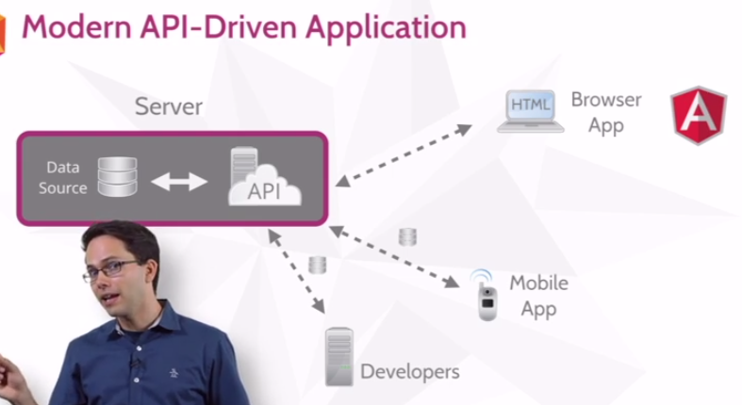

libraries

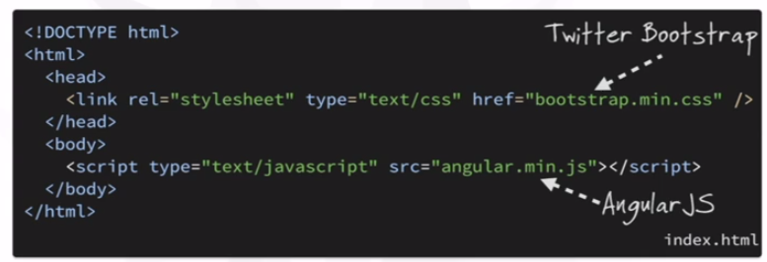

module

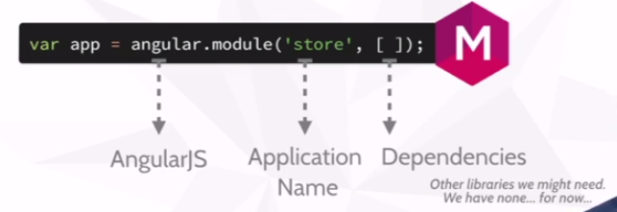

Directive (i.e. link html & js)

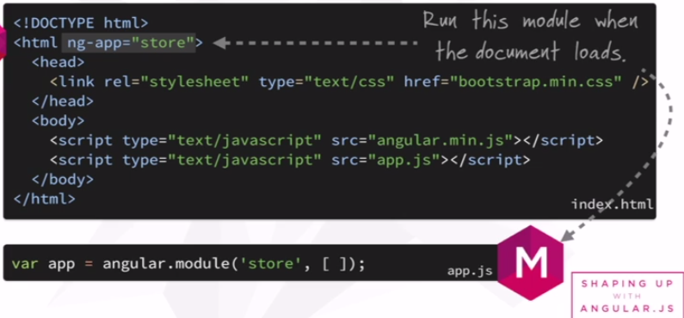

Controller within closure with property „product“ + Json data

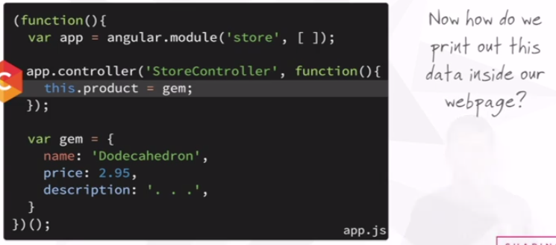

Attach …

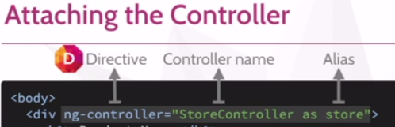

… access from within Html (assigned to div, only available within div)

Tricky: Html calls controller <-> presenter calling Html !!

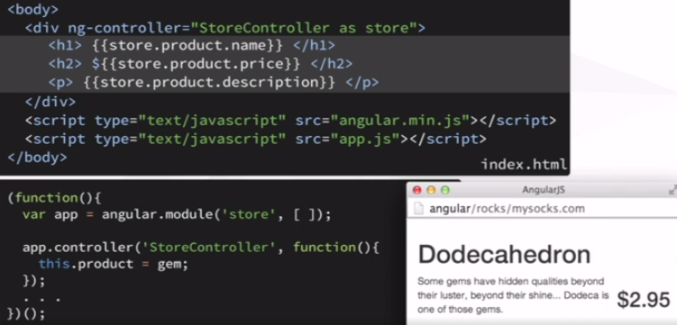

ngShow Directive

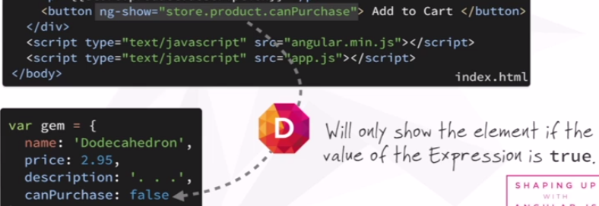

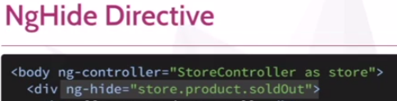

Directive to iterate through array …

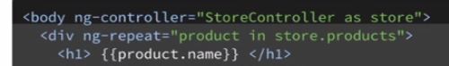

Summary

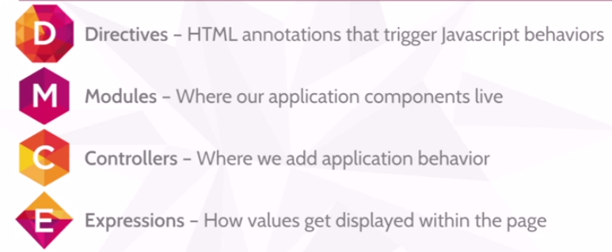

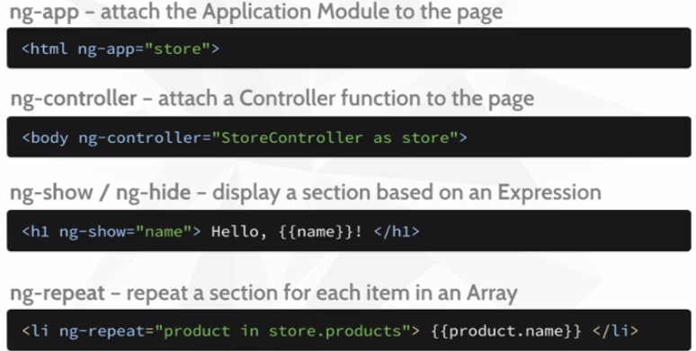

-----------  
-----------

Level 2

Pipe & filter -> display

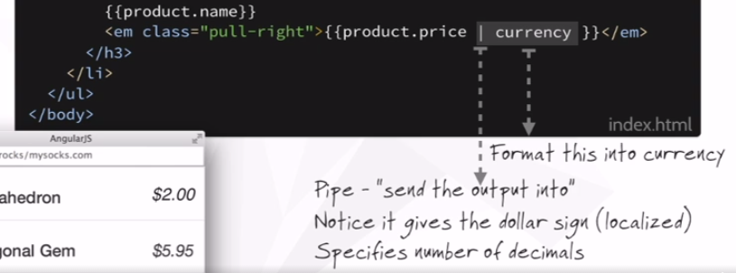

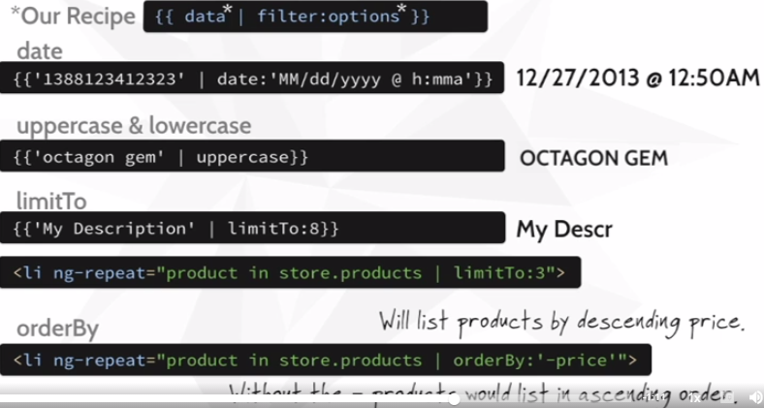

<img ng-src=“{{product….full}}“/> … otherwise loaded before angular!!

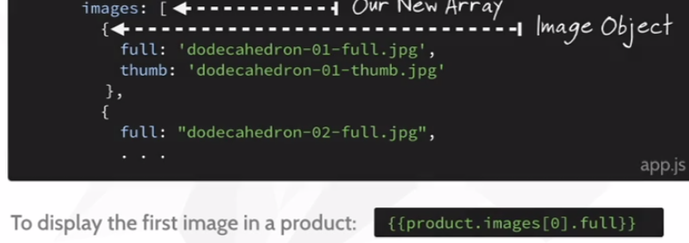

React to „length“ of array



Bootstrap „tab“ + angular „init“  
ng-init -> evaluate expression in current scope  
ng-class -> change color of „hoover-over button“

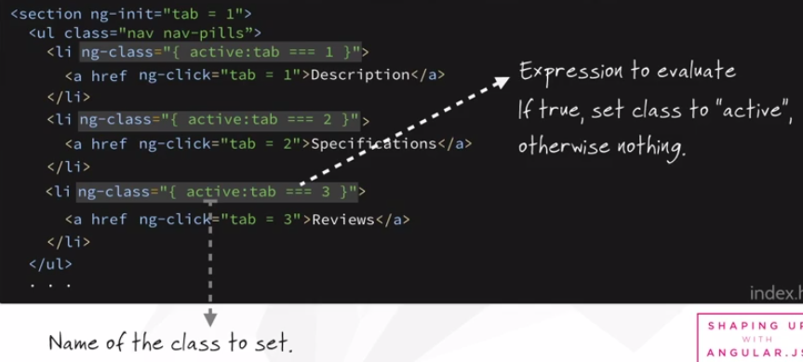

Assign „panel“ dynamically (onClick)

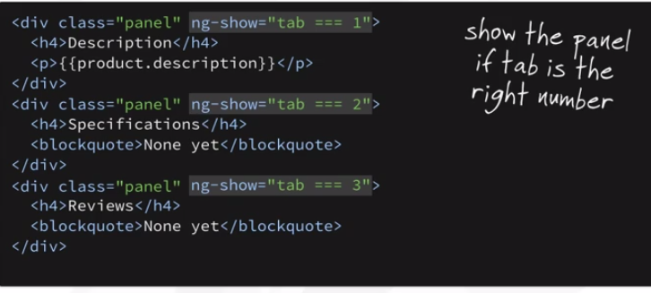

Pull logic out of Html !!



Important:  
ng-controller + alias „panel“  
ng-click -> sets controller value  
ng-class -> highlights selected button  
ng-show -> shows appropriate <div>  
{{product.xxx}} -> prints value of selected category

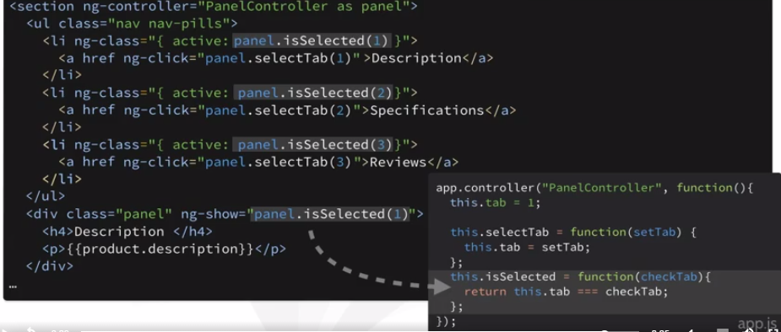

JS check for „null“ values

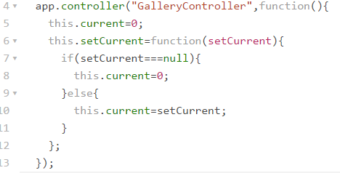

Use selected value to choose image (2-way data binding -> ng-src)

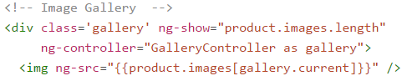

Tricky: no „{{tab}}“ variable defined explicitely…

-----------  
-----------

Level 3

Forms + variables -> model

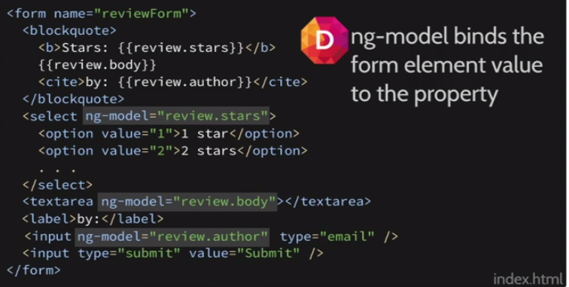

More binding …

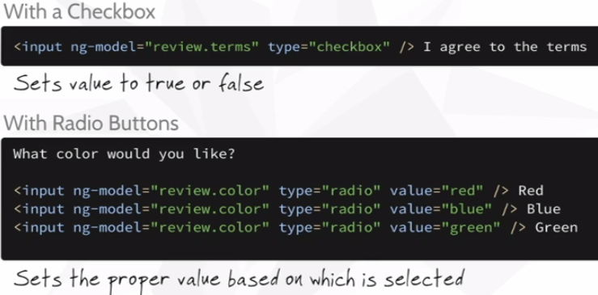

How to define „review“ variable (i.e. DataObject) in the most elegant way?  
1) js -> controller  
2) html -> ng-controller  
short-cut -> html -> „ng-init“

How to submit form?  
ng-submit -> call function

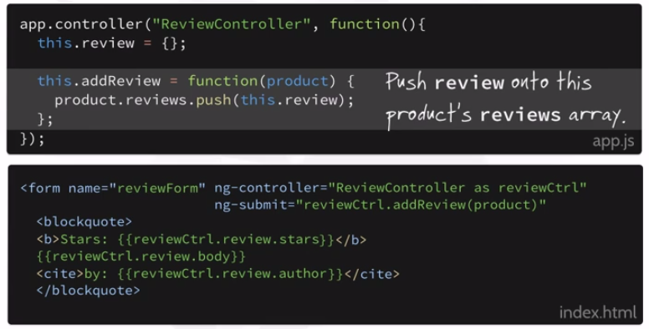

… and reset form input (2-way binding)

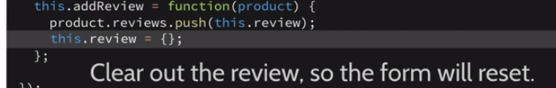

Javascript -> empty object & add to array

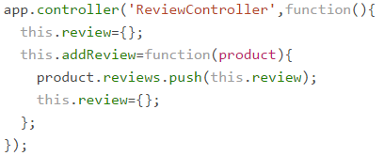

Validate

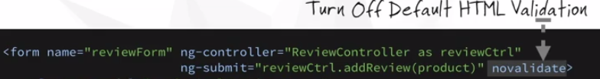

Validation (on Form)

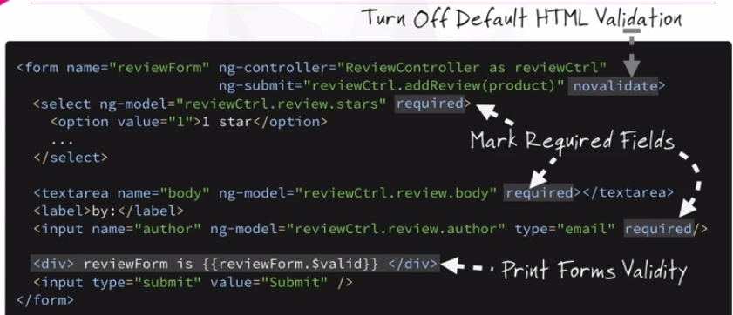

Validation (on Submit)

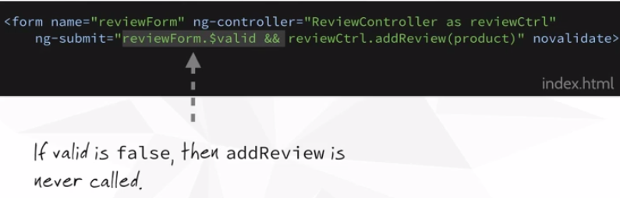

Highlight fields

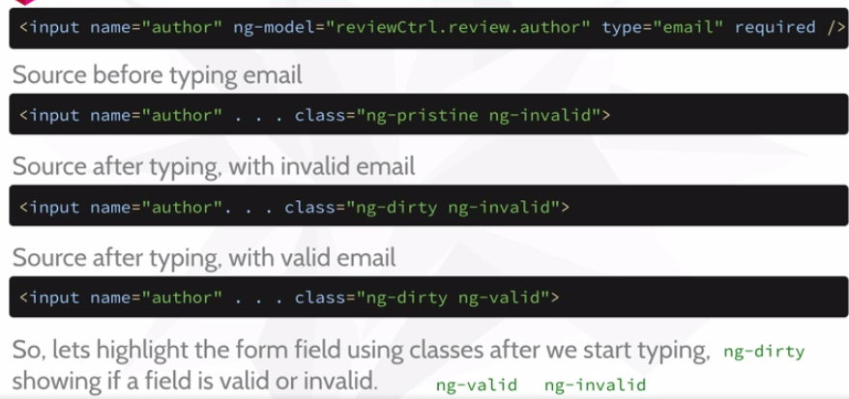

Valid -> Styles (no border, if „pristine“, i.e. un-touched)

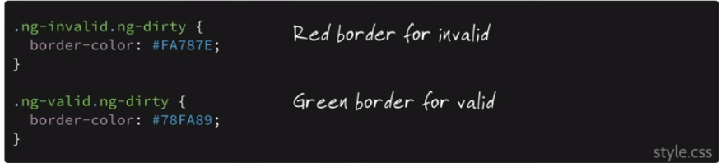

Rules

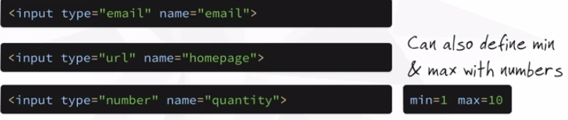

-----------  
-----------

Level 4

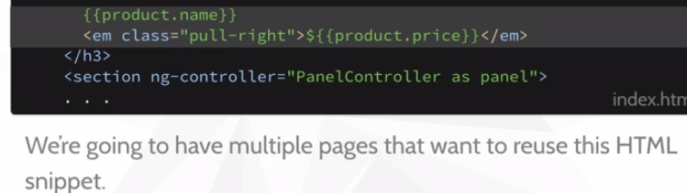

Snip & include (Ajax)

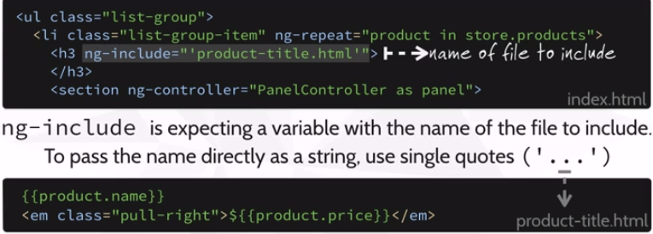

Html -> structure  
Directive -> behaviour -> tells what it does  
Custom Directive -> Custom Tags -> Expressiveness  
-> Template-Expansion

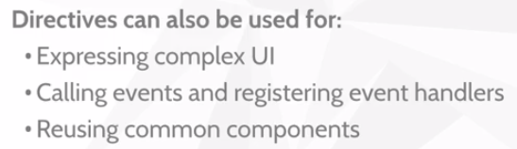

How to …

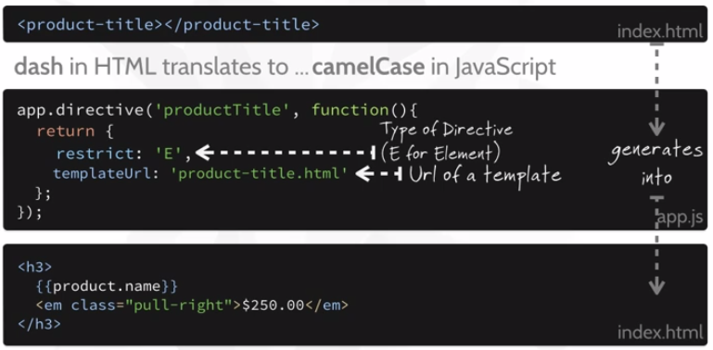

‚E‘ versus ‚A‘ -> element versus attrbute

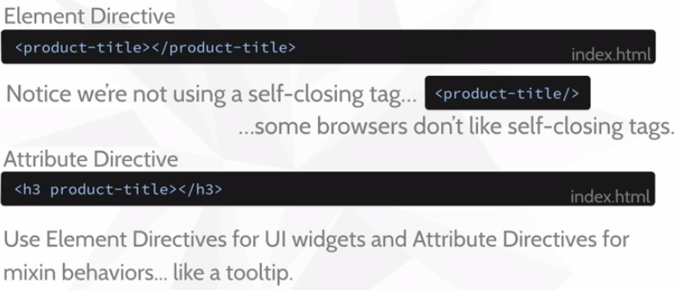

Move Controller & it’s alias (usually within Html) into custom directive

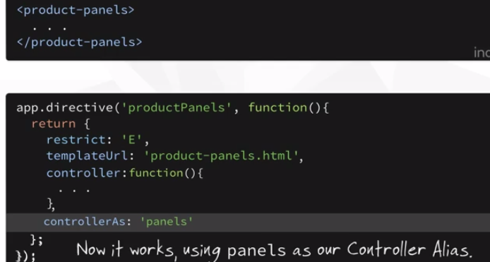

-----------  
-----------

Level 5

Modularize

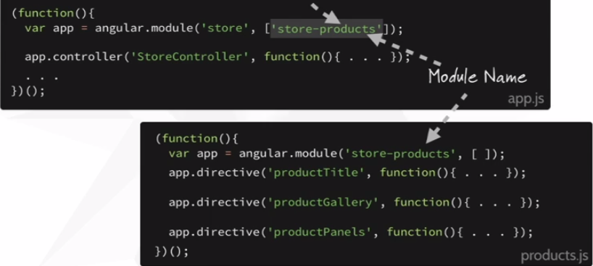

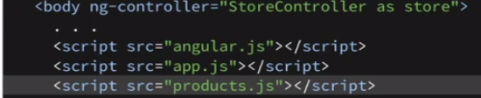

Live Date

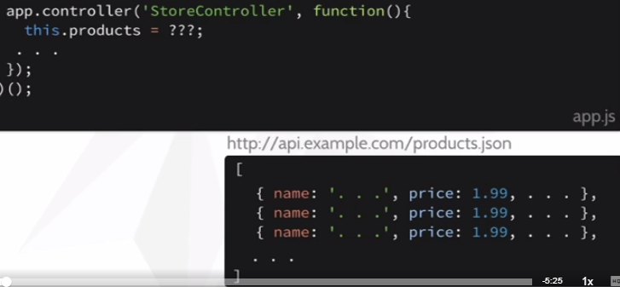

http – json -> via promise (asynch)

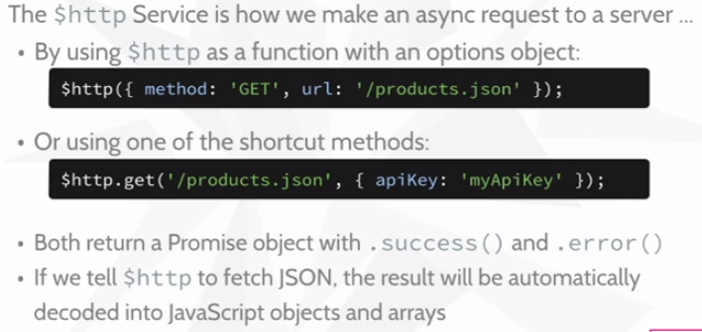

Dependency injection

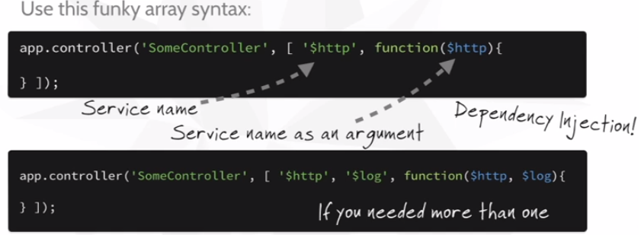

At runtime:

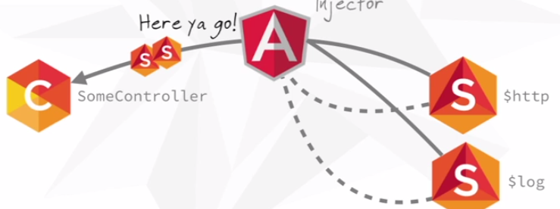

„this“ not available upon call-back !!

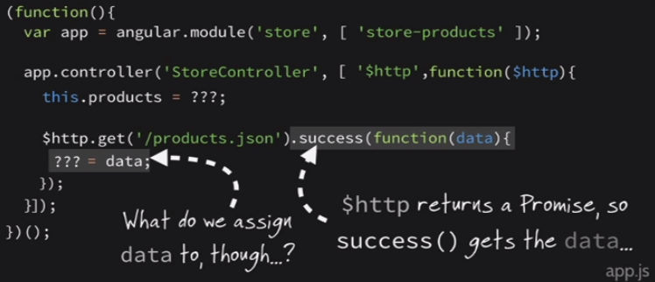

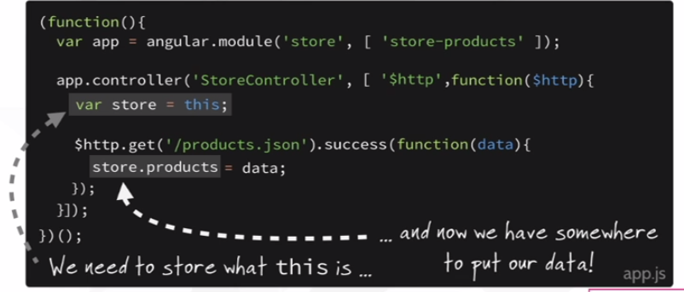

Auto-update of empty array (2-way binding)

